Venue directions
On the NSPR website for the conference, you can click on the venue names, which will open google maps with the location marked. Choose “directions”, your own location, and you can be directed to the place either walking or using transit.

Tickets: If you download the app called Ruter, you can buy tickets, get all departure times, your closest stop, and maps of where to walk. Buying tickets is more of a hassle, but they can be purchased at most 7-Eleven or Narvesen stores.

Day 1: Professorboligen, University of Oslo
Address: Karl Johans gate 47.
Nearest metro stop: Nationaltheateret.

All subway lines (t-bane) go to Nationaltheateret, and one will come every few minutes.
If you are at Stortinget, Jernbanetorget, or farther east, you must go westward.

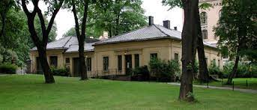

Day 2 and 3: Tøyen hovedgård.
Address: Oscars gate 45 (located inside the botanical garden).
Nearest metro stop: Tøyen.

All subway lines go to Tøyen, and one will come every few minutes.
If you are at Majorstuen, Nationaltheateret, Stortinget, Jernbanetorget, or farther west, you must go eastward.

